# LAB ASSIGNMENT-10

TASK-1:

Prompt:

Identify and correct the code

def add_numbers(a, b)

result = a + b

return reslt

print(add_numbers(10 20))

Code and Output:

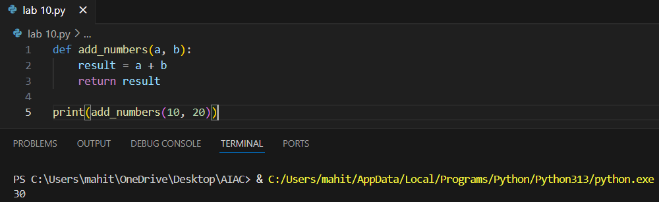

Code Explanation:



TASK-2:

Prompt:

Optimize inefficient logic while keeping the result correct.

def find_duplicates(nums):

duplicates = []

for i in range(len(nums)):

for j in range(len(nums)):

if i != j and nums[i] == nums[j] and nums[i] not in duplicates:

duplicates.append(nums[i])

return duplicates

numbers = [1,2,3,2,4,5,1,6,1,2]

print(find_duplicates(numbers))

Code and Output:

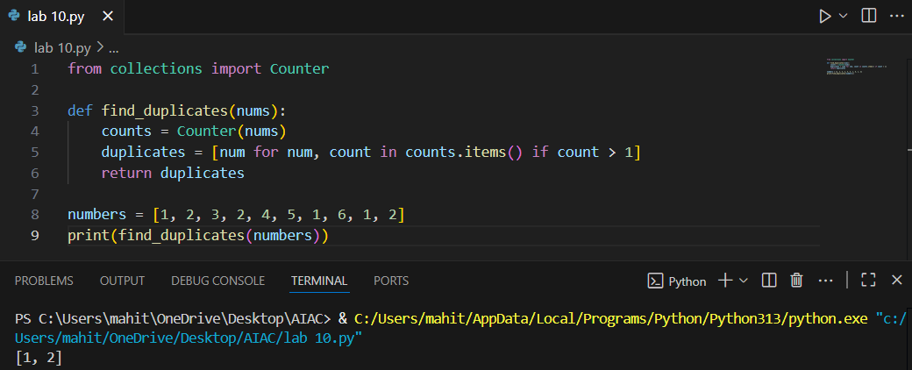

Code Explanation:

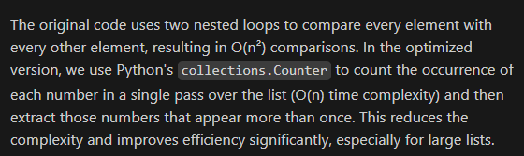

TASK-3:

Prompt:

Generate a Function renamed to calculate_factorial.

Proper indentation, variable naming, docstrings, and formatting.

Provide a more readable version.

def c(n):

x=1

for i in range(1,n+1):

x=x*i

return x

print(c(5))

Code and Output:

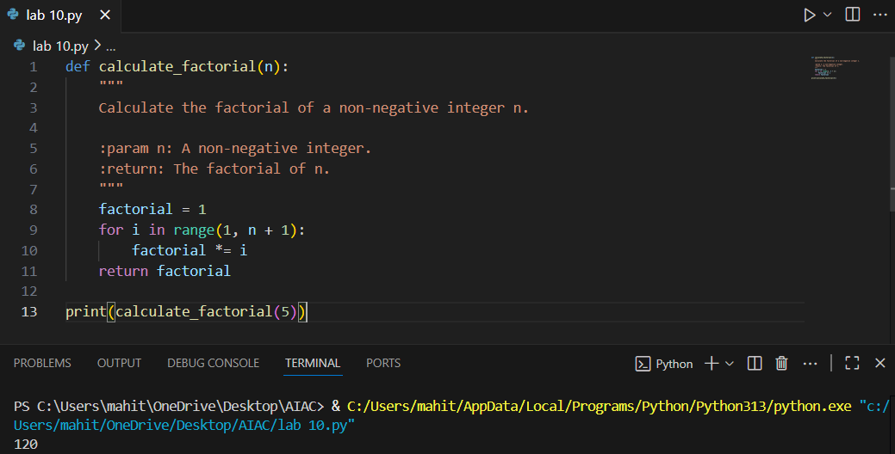

Code Explanation:

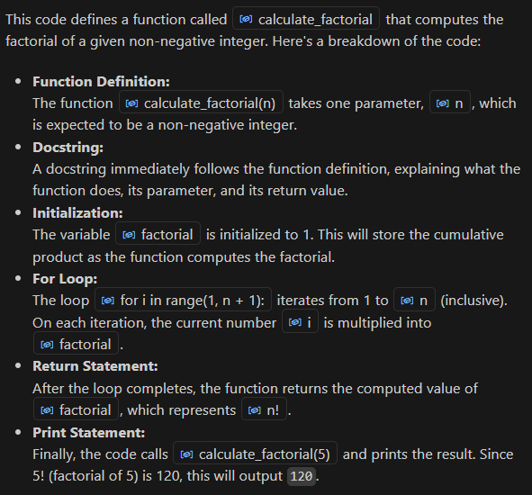

TASK-4:

Prompt:

Add security practices and exception handling to the code.

import sqlite3

def get_user_data(user_id):

conn = sqlite3.connect("users.db")

cursor = conn.cursor()

query = f"SELECT * FROM users WHERE id = {user_id};" # Potential SQL injection risk

cursor.execute(query)

result = cursor.fetchall()

conn.close()

return result

user_input = input("Enter user ID: ")

print(get_user_data(user_input))

Code and Output:

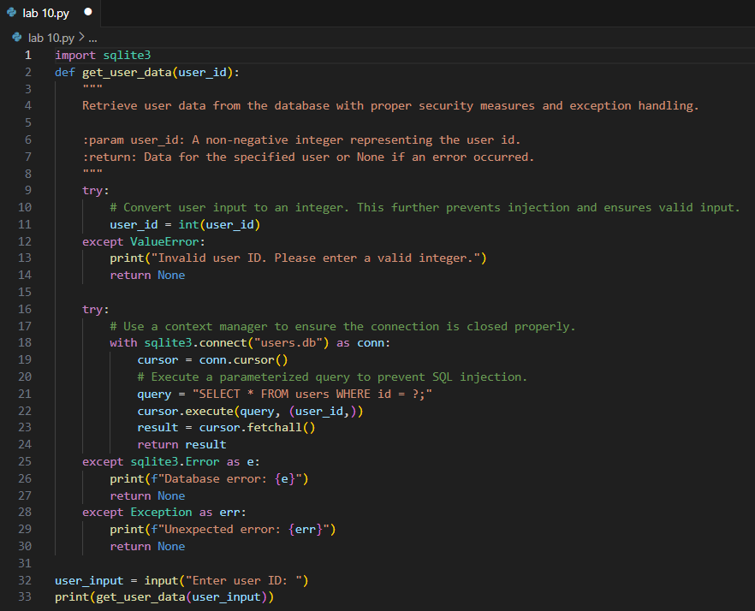



Code Explanation:

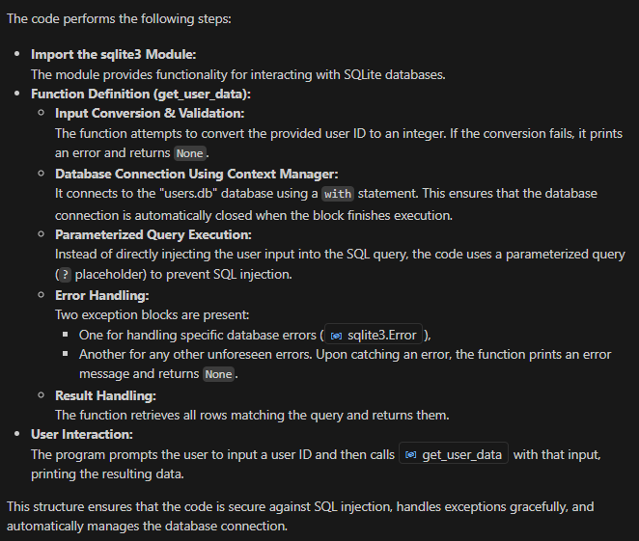

TASK-5:

Prompt:

Generate a review report for this messy code.

def calc(x,y,z):

if z=="add":

return x+y

elif z=="sub": return x-y

elif z=="mul":

return x*y

elif z=="div":

return x/y

else: print("wrong")

print(calc(10,5,"add"))

print(calc(10,0,"div"))

Output:

